Test Case: tc007_SPX_Dev5_Validacion_Boton_Edit_Administrador_Menu
Step 1 - Enter username and password and click to button Enter : Credentials Entered
Image file-name: QC_Testing-tc007_SPX_Dev5_Validacion_Boton_Edit_Administrador_Menu-nov. 20 2025, 06 44 33 p. m.

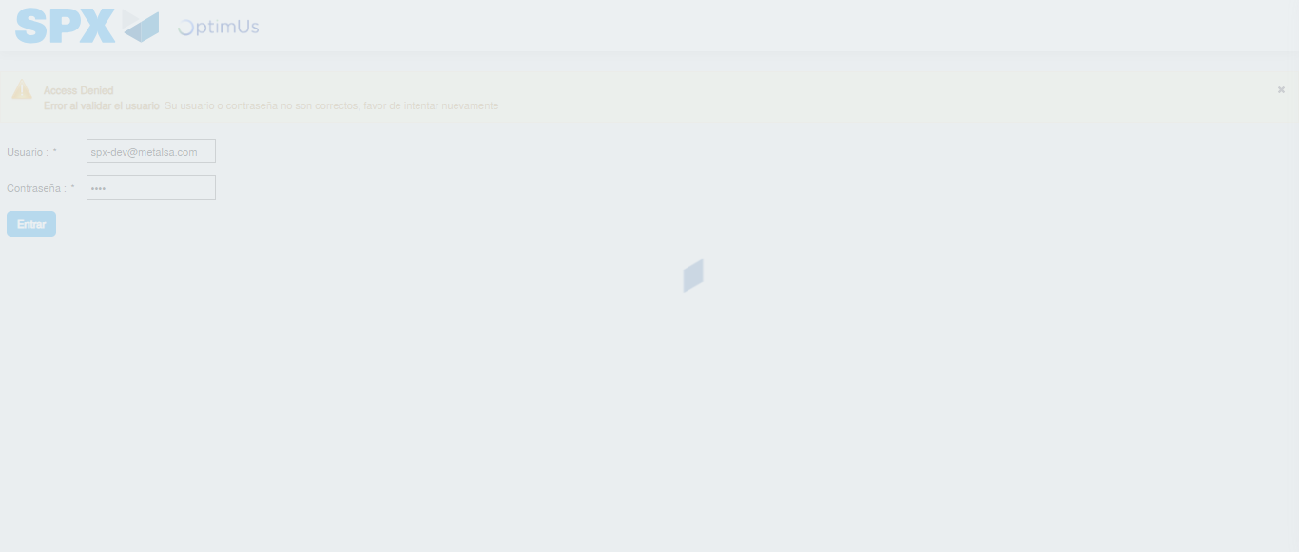Image file-name: QC_Testing-tc007_SPX_Dev5_Validacion_Boton_Edit_Administrador_Menu-nov. 20 2025, 06 44 34 p. m.

Step 2 - Select to UEN and Access to Administrador Roles Menu: UEN Correctly selected and Correct access
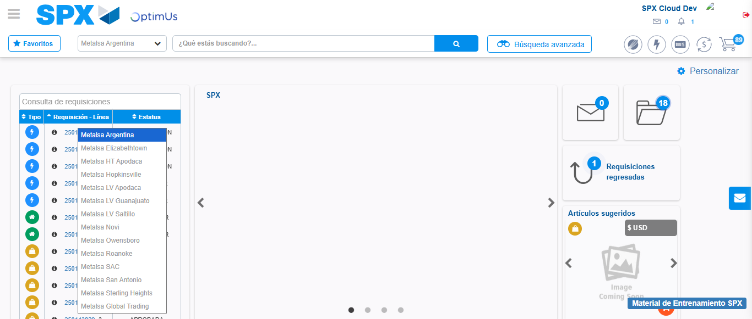Image file-name: QC_Testing-tc007_SPX_Dev5_Validacion_Boton_Edit_Administrador_Menu-nov. 20 2025, 06 44 37 p. m.

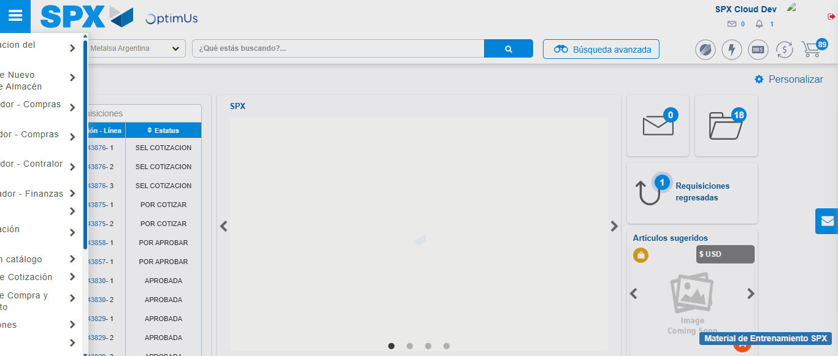Image file-name: QC_Testing-tc007_SPX_Dev5_Validacion_Boton_Edit_Administrador_Menu-nov. 20 2025, 06 44 38 p. m.

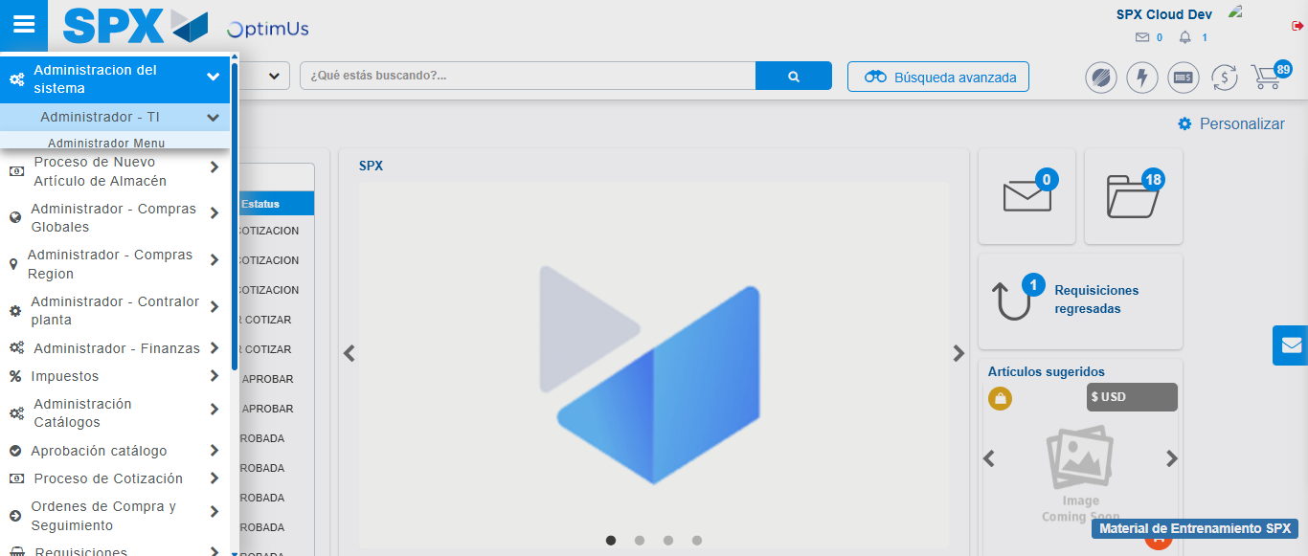Image file-name: QC_Testing-tc007_SPX_Dev5_Validacion_Boton_Edit_Administrador_Menu-nov. 20 2025, 06 44 39 p. m.

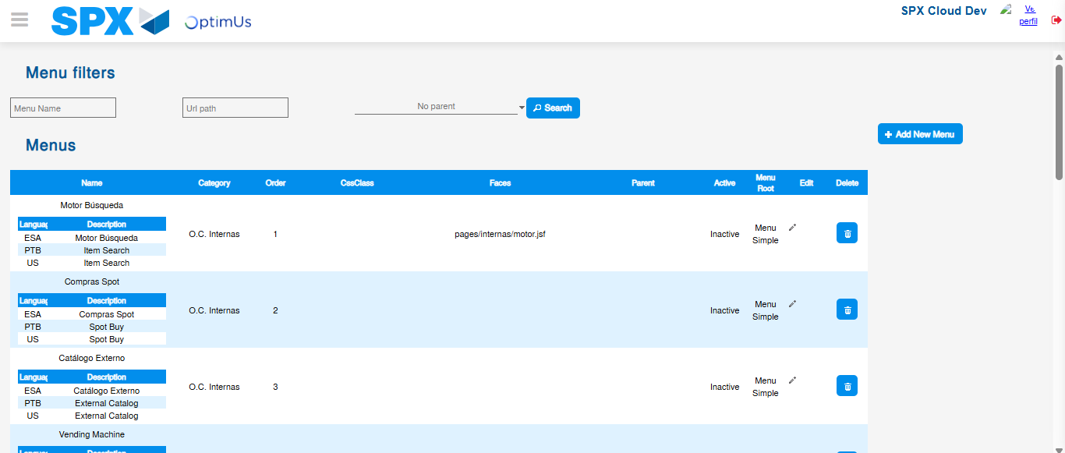Image file-name: QC_Testing-tc007_SPX_Dev5_Validacion_Boton_Edit_Administrador_Menu-nov. 20 2025, 06 44 42 p. m.

Step 3 - Add new menu and edit fields: New menu successfully registered
Image file-name: QC_Testing-tc007_SPX_Dev5_Validacion_Boton_Edit_Administrador_Menu-nov. 20 2025, 06 44 42 p. m.

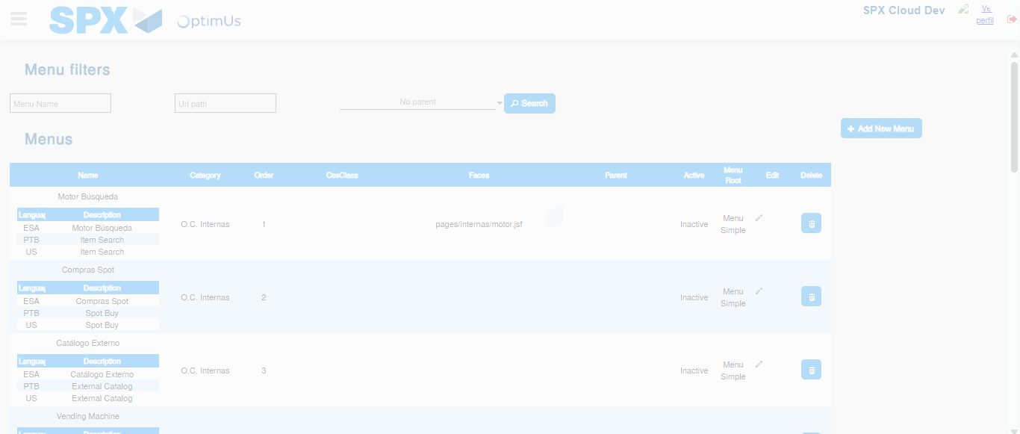Image file-name: QC_Testing-tc007_SPX_Dev5_Validacion_Boton_Edit_Administrador_Menu-nov. 20 2025, 06 44 43 p. m.

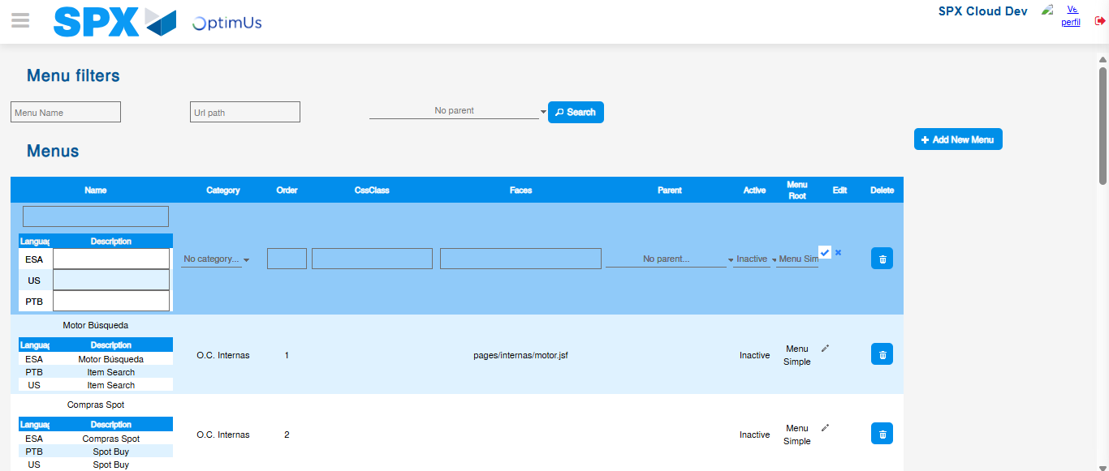Image file-name: QC_Testing-tc007_SPX_Dev5_Validacion_Boton_Edit_Administrador_Menu-nov. 20 2025, 06 44 46 p. m.

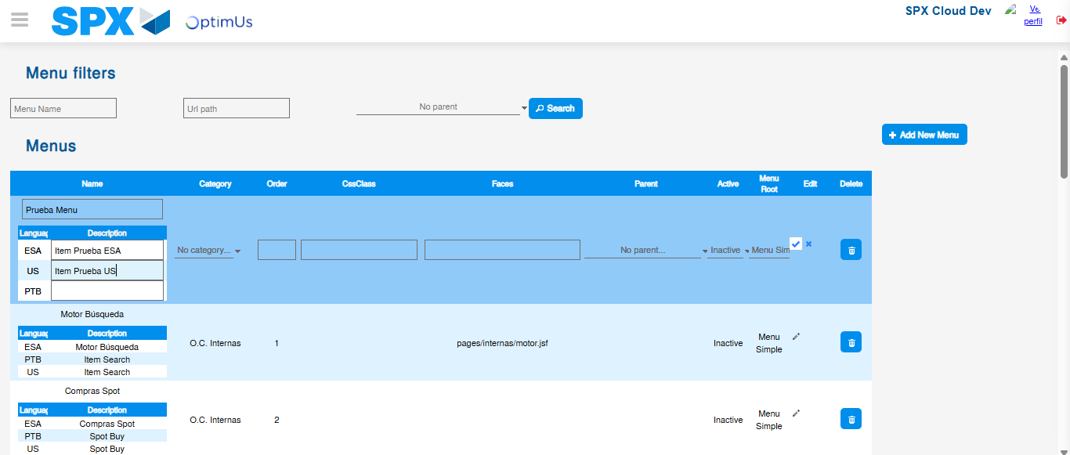Image file-name: QC_Testing-tc007_SPX_Dev5_Validacion_Boton_Edit_Administrador_Menu-nov. 20 2025, 06 44 47 p. m.

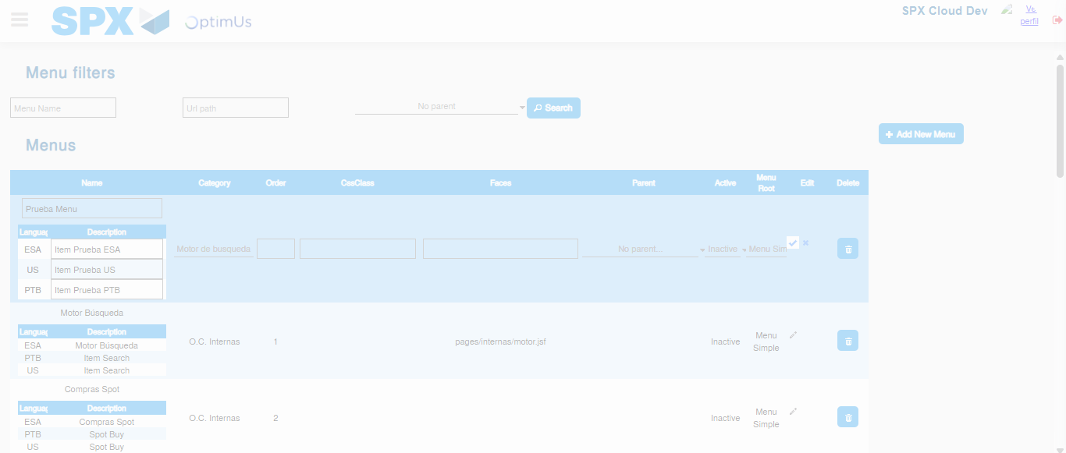Image file-name: QC_Testing-tc007_SPX_Dev5_Validacion_Boton_Edit_Administrador_Menu-nov. 20 2025, 06 44 48 p. m.

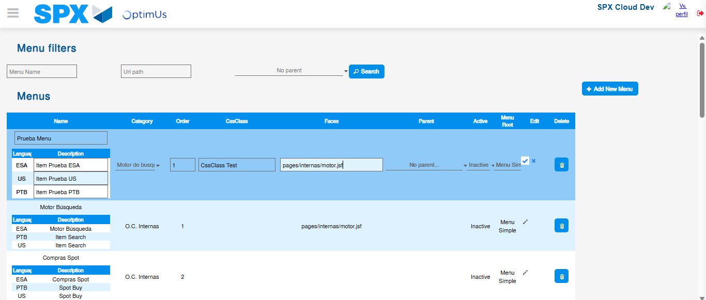Image file-name: QC_Testing-tc007_SPX_Dev5_Validacion_Boton_Edit_Administrador_Menu-nov. 20 2025, 06 44 49 p. m.

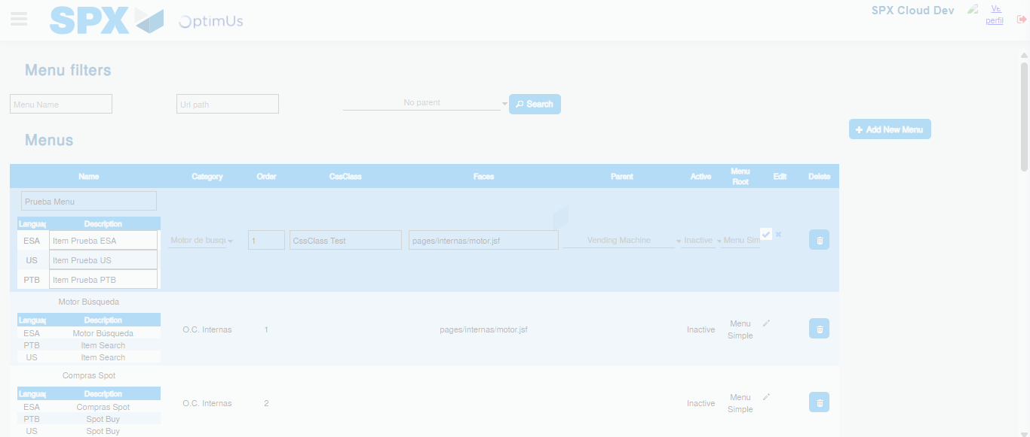Image file-name: QC_Testing-tc007_SPX_Dev5_Validacion_Boton_Edit_Administrador_Menu-nov. 20 2025, 06 44 50 p. m.

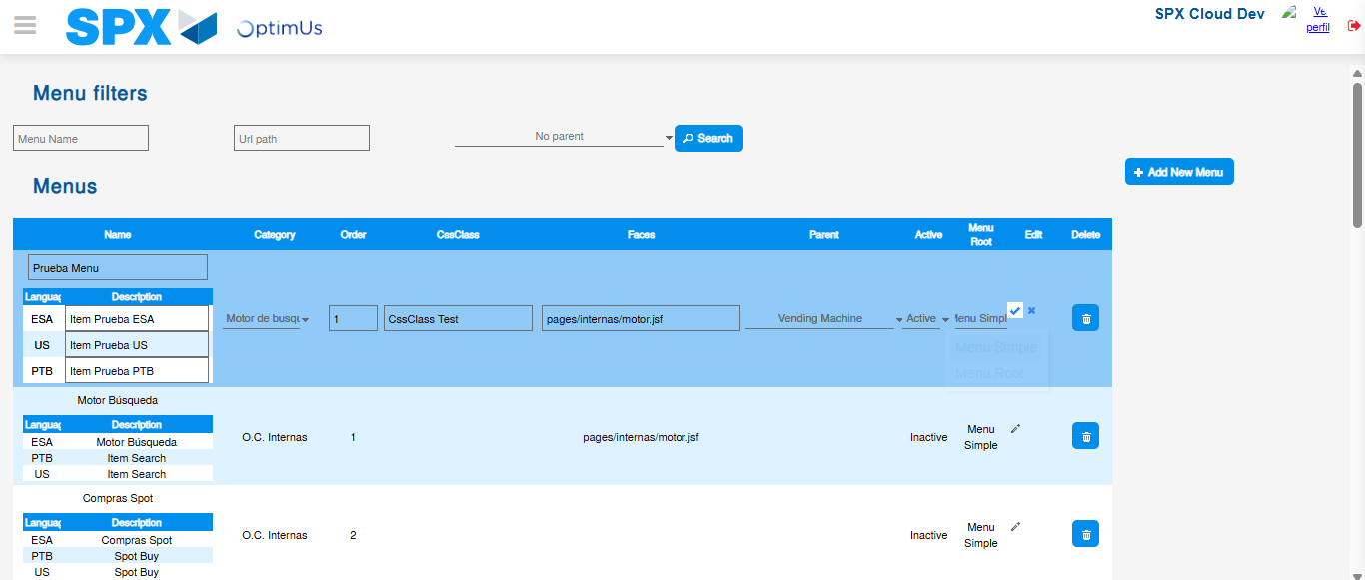Image file-name: QC_Testing-tc007_SPX_Dev5_Validacion_Boton_Edit_Administrador_Menu-nov. 20 2025, 06 44 51 p. m.

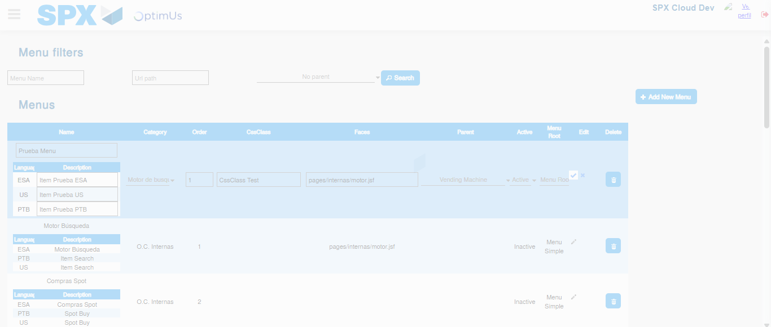Image file-name: QC_Testing-tc007_SPX_Dev5_Validacion_Boton_Edit_Administrador_Menu-nov. 20 2025, 06 44 52 p. m.

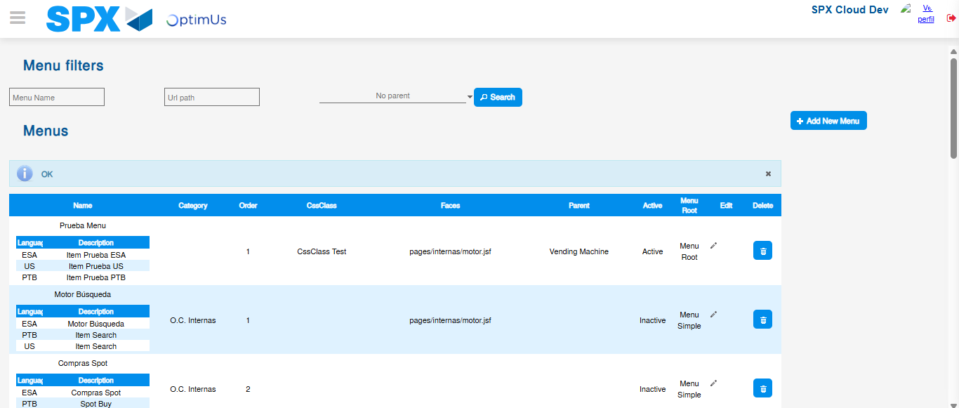Image file-name: QC_Testing-tc007_SPX_Dev5_Validacion_Boton_Edit_Administrador_Menu-nov. 20 2025, 06 44 55 p. m.

